Meeting Minutes

Attendees: Carolyn Berger, Kathy Henkelman, Karla Gabral, Mara Resendiz, Chris Kolcz, Ray Szull, Agnes Elyakine, Colleen Carlberg

Committee Leaders:
Spirit Wear- Kathy Henkelman
Shirts – Agnes Elyakine, (assiting Colleen Carlberg and Mara Resendiz)
Dairy Queen- Ray Szull and Chris Kolcz
Coupon Book Fundraiser- Colleen Carlberg

Mrs Bergers report:

Grove Orchestra Association (GOA) Meeting
The next GOA meeting is on Monday, October 15 at 6:30 p.m. in the orchestra room. All parents are welcome to attend and find out how to support the orchestra!

Looking ahead
The Fall concert for the 8th Grade Orchestra is just one month away on Thursday, October 18!

The EGHS Junior/Senior High Night performance is on Thursday, November 1. This is the second performance from the 8th Grade Orchestra.

The Winter Orchestra Concerts are on Wednesday, January 16 at 5:30 p.m. (5th and 7th Grade Orchestras) and 7:30 p.m. (6th and 8th Grade Orchestras).

President/Treasures Report: Colleen Carlberg
Outstanding balance for 2018/2019 in the bank is $1867.95
Budget 2018/2019 :

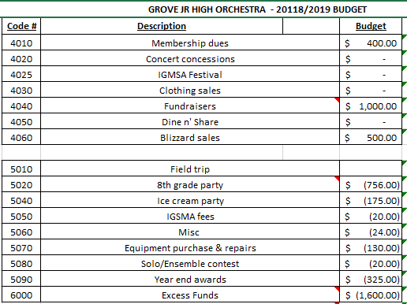

Discussion Items:
Membership dues flyer- Mrs. Berger is going to provide the soft copy to Colleen for revision and sending out

Fundraiser: Mrs. Berger to provide list of student names to get a student count and order the coupon books for the fundraiser

Sign up Genius: Need volunteer to create the master list for the orchestra for use by all committee leads

Next meetings(2nd Monday of each month we can change the date if needed) 6:30 pm:

October 15th
Nov 12th
No Dec meeting
Jan 14th

If you have any questions please feel free to reach out to colleen.carlberg@yahoo.com

