Date: ___________ Music period: _________ Grade:______

Student name:

____________________________________________________________

Parent signature:

____________________________________________________________

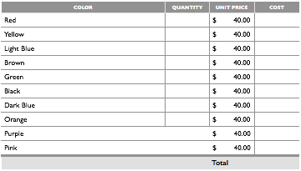

Payments must be made in CASH ONLY. Order Forms must be turned in by the last day of the Quarter. Ukuleles can be back-ordered, especially popular colors, so there is no way to know how long they will take to arrive. You can also go to www.musiciansfriend.com and order them yourself.
