Better for the body

Directions: Write down the purpose and answer any questions in complete sentences.

Purpose: What food burns longer (having more energy for the body)?

Procedures for Marshmallow
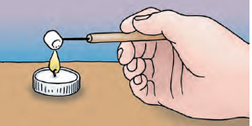
- Pour exactly 20 mL of water from the large beaker into the graduated cylinder.
- Pour the 20 mL of water from the cylinder into the test tube. Put the test tube clamp securely around the test tube.
- Insert the thermometer into the test tube (hold only the red rubber part of the thermometer) and allow 30 seconds of wait time before reading.
- Record the temperature under “starting temperature” on the data table under marshmallow.
- Place a candle in a pie pan. Your teacher will light a candle for your group.
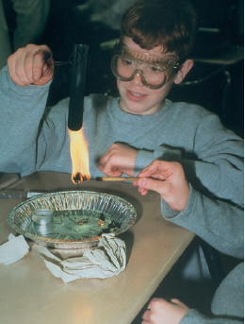
- Tear off approximately ¼ of the marshmallow. The piece of marshmallow should be close in size to the shelled sunflower seed.
- Stick the needle into a marshmallow and hold it over the flame until the marshmallow ignites (see the picture on the right). AS SOON as the marshmallow ignites, have your partner extinguish the candle flame and move the candle to the side of the pie pan.
- Immediately start the stop watch
- Quickly place the marshmallow so that the tip of the flame is touching the bottom of the test tube. Hold it there until the flames goes out. And Stop the stopwatch.
- Record the time in your data table.
- Wait 25 seconds. Read the temperature of the thermometer in the test tube. Record the in the test tube under “final temperature” of the marshmallow.
- Dip the food in the 250-m beaker of water for a moment to allow it to cool. Remove the remains of the marshmallow from the needle.
- Rinse the test tube and refill it with the 20 mL of fresh water from the Large Beaker. Repeat steps for trials 2 and 3.

Procedures for Sunflower Seed
- Press on the side of the sunflower seed to crack open the shell.
- Remove the seed from the shell. Stick the dissecting needle into the sunflower seed by gently twisting the wooden handle of the needle back and forth with your thumb and forefinger until the point of the needle is securely fixed in the sunflower seed.
- As shown in the image follow the same procedures that you carried out with the marshmallow. Record your data table under sunflower seed.

 | Marshmallow |  |  |  | Sunflower Seed
 | Starting Temp | Ending Temp | Temp  Change | Time (Seconds) | Starting Temp | Ending Time | Time (seconds) | Temp  Change
Trial 1
Trial 2
Trial 3
Average
Data Table:

Analyzing the data:
- Which substance burned for a longer amount of time on average?
- How much longer did that substance burn than the other?
- Which substance increased the most in temperature?
- How much more did it increase in temperature than the other?
- Why do you think the substance burned both longer and increased the temperature of the water more over the other?

