Blood Typing

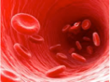
Background information:
- A donor is someone who is giving blood to a person.
- A receiver is someone who is getting blood from a person.

Procedures:
1. Read all the procedures before you begin this inquiry.
2. In the A row (right to left) put 2 drops of red food coloring in each of the boxes.
3. In the B row (right to left) put 2 drops of blue food coloring in each of the boxes.
4. In the AB row put 2 drops of purple food coloring in each of the boxes.
5. In the O row put 2 drops of clear food coloring in each of the boxes.
In each of the columns (up and down) place 2 drops of the columns food coloring color on top of the food coloring that is already present in each box.
With the stir stick that is provided mix the drops in each box together. If the color changes from the original color then mark an (X) in the box. If there is no color change put a (☺ ).
After mixing each color with the stir stick make sure to stir it in the beaker of water labeled “rinse.”

Data Table:
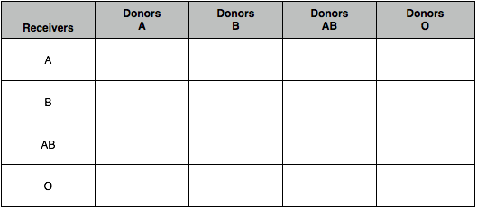

Analyzing the Data:

- What blood types can blood type A be a donor to?

- What blood type is the “universal donor”?

- What blood type is the “universal receiver”?

- A person is in a car accident and looses a lot of blood. This person has Type B blood. What type of blood can this person receive?

- A person is donating blood at a blood drive. The nurse tells this person that their blood is important because it can be used for anyone. What blood type is this?

- While on a deserted island a person is injured who has type AB blood. There are 4 people on the island. One has type A blood, one has type B blood, one with type O blood and the injured person. How many people can donate their blood to this person?

After reading Blood: Life’s liquid answer the following questions:
- What is plasma?

- Why does blood look so dark (blue) in your veins near the surface of our skin?

- When you skin is cut why do you get a scab?

- What really are bruises?

About 5 million Americans need blood transfusions every year, for all sorts of reasons. Sometimes, a transfusion is an emergency (like losing blood after an accident). Sometimes it's expected (as with treatment for cancer).
Whatever the reason, blood transfusions are one of the most common hospital procedures.
While transfusions are common, there's a lot more to them than just taking blood from one person and using it to help someone else. It's very important to keep the blood supply safe. So, each unit of blood goes through many tests to check for infectious diseases and establish the blood type.

Four Blood Groups...
It might seem like blood is blood — it all looks pretty much the same to the naked eye. But although all blood contains the same basic components (red cells, white cells, platelets, and plasma), not everyone has the same types of markers on the surface of their red blood cells. These markers (also called antigens) are proteins and sugars that our bodies use to identify the blood cells as belonging in our own system.
Blood cell markers are microscopic. But they can make the difference between blood being accepted or rejected after a transfusion. So medical experts group blood into types based on the different markers.
The four main blood groups are:
- Type A. This blood type has a marker known as "A."
- Type B. This blood type has a marker known as "B."
- Type AB. The blood cells in this type have both A and B markers.
- Type O. This blood type has neither A or B markers.

Plus Rh Factor...
Some people have an additional marker, called Rh factor, in their blood. Because each of the four main blood groups (A, B, AB, and O) may or may not have Rh factor, scientists further classify blood as either "positive" (meaning it has Rh factor) or "negative" (without Rh factor).
Having any of these markers (or none of them) doesn't make a person's blood any healthier or stronger. It's just a genetic difference, like having green eyes instead of blue or straight hair instead of curly.

