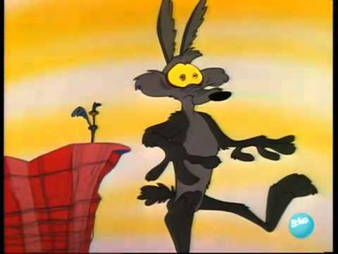
Intro to why do things fall

Directions:
- Read the 5 questions then watch the video below. Answer the questions after you have watched the entire video.

Click here for the video

- I think objects fall downward because…
- I believe ________ (object 1) falls at a different/the same rate as ________ (object 2).
- I believe that ________ makes an object fall at a faster/slower speed.
- An object’s size does/does not affect the way the object falls because…
- An object’s shape does/does not affect the way the object falls because...

Directions:
- Watch the video below then answer the following questions:

Click here for video
- What is gravity?
- What is air resistance?

Directions:
- Take one regular flat sheets of paper and one crumbled up sheet of paper.
- Drop them both from the same height at the same time and observe? (do this twice)
- Answer the following the questions

- Which piece of paper had the slowest falling speed?
- Explain why you think that piece of paper fell slowest.
- Does the shape of an object affect the way the object falls?
- Explain your answer to question 10.
- Why do objects on Earth fall at different rates?

