Interactive Seasons:
Directions: Answer the following questions using the interactive
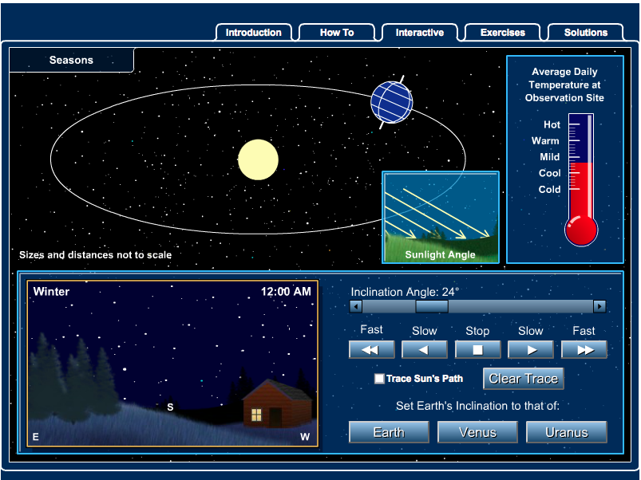
- Find the words “inclination angle” what does changing this change on the screen?

- Why do you think the change in the problem above effects the temperature?

- Change the “inclination angle” to 23 or 24˚. Why do you think you have to change this number to 23 or 24?

- What season do you notice has the most daylight for the day?

- Grab the “earth” on the picture on the top left and move the Earth back and forth during the summer season. About how many hours in the summer is the sun up for?

- What season do you notice has the least amount of daylight for the day?

- Grab the “earth” on the picture on the top left and move the Earth back and forth during the winter season. About how many hours in the winter is the sun up for?

- What do you notice happens to the planet in the upper left when you click on “Venus”?

- Why do you think what you choose for an answer above happened?

- What do you notice happens to the planet in the upper left when you click on “Uranus”?

- Between Uranus and Venus which has a higher “ecliptic” ?

- Why do you think the planet you choose above has a higher ecliptic?

