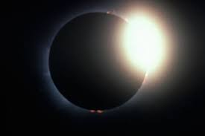
Moon Phases
Investigating Lunar and Solar Eclipses

Directions: Write down the purpose, the background information and Answers to any of the questions in the procedures.

Purpose: What has to happen for a solar or lunar eclipse to occur?

Background information:
Eclipse: An eclipse occurs when one object in space blocks something from seeing another object in space.
Full moon – when the Earth is between the Sun and the moon, and the illuminated side of the moon is facing towards the Earth.
New Moon – when the Moon is between the Sun and Earth and the illuminated side is facing away from Earth.

Hypothesis:
If I change the position of the _____ to be directly between the Sun and _____ then there will be a Lunar Eclipse.
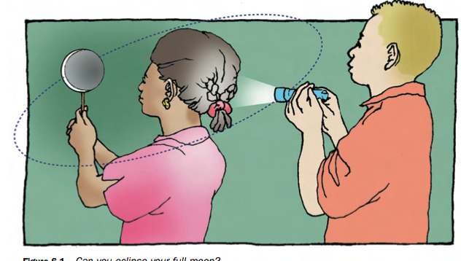
Procedures:
- In your group have 2 people model a Full Moon using the large white sphere (the Moon), a flashlight (the Sun), and yourself (Earth).

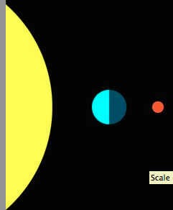
- Model the conditions under which a Full Moon is totally eclipsed (all light is blocked from the moon), as shown in the picture. Share roles with your group so that everyone has a chance to model Earth. What object is casting a shadow on the Moon? Write on your paper the words “Total Lunar Eclipse,” in Box 1. Draw this type of eclipse in the first box making sure to label the Moon, Sun, and Earth in your drawing. Draw in where the shadow is coming of the Earth to the moon.

- Your picture should look similar to the one on the right.

- Answer questions 2 & 3 on the worksheet.

- Now model a New Moon using your sphere (Moon), flashlight (Sun), and yourself (Earth).

- Model the conditions under which a New Moon can totally eclipse the Sun’s light (light if fully block from your eyes). Have your partner examine the shadow cast by the new moon. Where does the shadow made by the Moon fall? Write on your paper the words “Total Solar Eclipse,” in box 4 of your worksheet. Draw this type of eclipse also in box 4 making sure to label the Moon, Sun, and Earth in your drawing. Draw in where the shadow is coming of the Moon to the Earth.

- Answer questions 5, 6, & 7 on the worksheet.

- Show your completed worksheet to Ragaller.

- Read the article, “Eclipse Reading” from the teacher’s website.

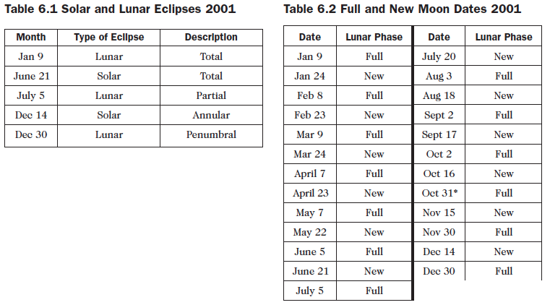

Analyzing Data:
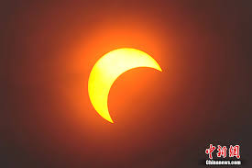
Directions: Use the information in Table 6.1 Solar and Lunar Eclipses 2001, Table 6.2 Full New Moon Dates 2001, the reading, and your observations from the this inquiry to answer the following questions. Put part of the question back into the answer.

- Using data table 6.2, explain the pattern you see in the lunar phases.
- During what phases does a lunar eclipse occur? Give one date as an example. (Use the data tables)
- During what phase does a solar eclipse occur? Give one date as an example. (Use the data tables)
- How many lunar eclipses occurred during the year 2001? (Use the data tables)
- How many solar eclipses occurred during the year 2001? (Use the data tables)
- Did an eclipse occur with each full and new moon? Explain why or why not. (Use the data tables)
- What part of a shadow do you have to be in to see a total solar eclipse? (Reading)
- What part of a shadow do you have to be in to see a partial solar eclipse? (Reading)
- Why do Solar Eclipses occur less often than Lunar Eclipses? (Lab reflection)
- Compare and contrast a Total Eclipse to a Partial Eclipse. (Lab reflection)
- Compare and contrast Lunar Eclipse to a Solar Eclipse. (Lab reflection)
- Explain why your hypothesis was correct or incorrect. (Lab reflection)
- Google when the next total lunar eclipse will occur in Chicago.
- Google when the NEXT total solar eclipse will occur in Chicago.
- Why do you think it will take about eighty-eight years before the next total solar eclipse?

