Eclipse Interactive Extension

Directions: Use the interactive web link called “Eclipse Interactive” then answer the following questions on a sheet on notebook paper Click Here

- What do you notice about the direction of the shadow, compared to the Sun, as you move the moon or Earth around?
- What do you notice about the size (width) of the Umbra or Penumbra as you move the moon or Earth further way from the Sun?
- What pattern do you notice about the length of the Umbra shadow as you move Earth or moon closer to the Sun?

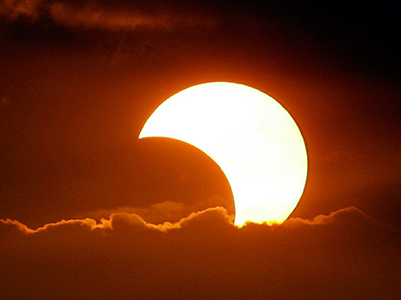
To move on to part two of this extension Click Here

- Does the Moon revolve clockwise or counterclockwise around the Earth?

Now set the “Tilt of Orbit” to about 3 degrees and again watch one complete orbit.

- Do eclipses occur now?
- Why do you think they do not?

In real life, the tilt of the Moon’s orbit is about 5 degrees.
- Should the Moon cover the Sun as it moves past?

Reset the orbital tilt to zero degrees and arrange a perfect solar eclipse. Vary the size of the Moon.
- Would a solar eclipse look dramatically different in the Moon were 20 percent large?
- Would a solar eclipse look different if it were 20 percent smaller?
- Would a lunar eclipse look dramatically different?

Directions: Double Click on the image of the Monkey below to play the short video. You should wear your ear buds if doing this in class.

