Interactive Transverse Wave Lab

Directions: Answer the questions below using the interactive website found on my website: https://phet.colorado.edu/en/simulation/wave-on-a-string
Purpose: See the relationship between frequency, amplitude and wave speed.
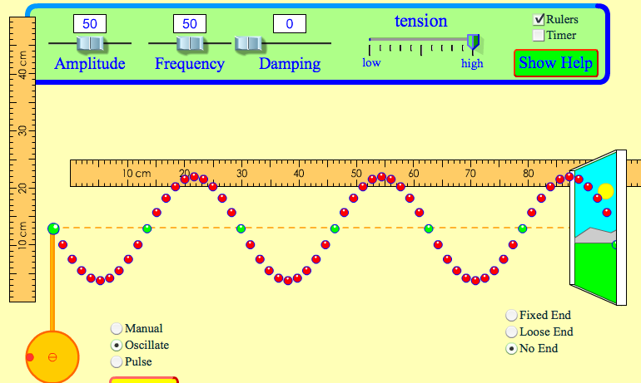
Set Up:
- Change the button from “manual” to “oscillate”
- Change the button from “fixed end” to “no end”
- Lower the dampening to “none”.
- Keep the tension at “high”
- Change the frequency to 2 Hz
- Change the amplitude to 1 cm
- Check the ruler box.
- You MUST move the rulers around to measure!

Procedures:
- Press the play button to make the wave.
- Click the pause button where you can easily see two consecutive crests or troughs.
- Using the horizontal ruler, what is the wavelength of the wave (including the unit)?
- Is the wavelength the same throughout the entire medium?
- Using the vertical ruler, what is the amplitude of the wave (including the unit)?
- Is the amplitude the same throughout the entire wave?
- What is the speed of this wave (unit)?
- Press the “pause” button again.
- Change the amplitude setting to .5 cm.
- Using the horizontal ruler, measure the wavelength of this wave.
f) What is this new wavelength?
g) Is the wavelength the same throughout the entire medium?
h) Using the vertical ruler, measure the amplitude of the wave in cm?
i) Is the amplitude the same throughout the entire wave?
j) What is the speed of this wave? (wavelength x frequency)
- Click the “pause” and change the frequency to 1.00 Hz.
k) What is the wavelength of this wave in cm?
l) What is the speed of this wave?
- Raise the frequency setting to 2.0 Hz.
m) What is the wavelength of this wave in cm?
n) What is the speed of this wave?
- Raise the frequency setting to 3.0 Hz.
o) What is the wavelength of this wave in cm?
p) What is the speed of this wave?

Continue on the next page
- Move the frequency setting to 0.
  - What do you notice about the wave now?
  - Why would a frequency of 0 Hz not make a wave? (Hint: think of the definition of frequency).

Properties of Waves Questions:
- If you increase the frequency of a wave, how (if any) is the amplitude affected?
- If you decrease the frequency of a wave, how is the wavelength of the wave affected?
- If you increase the amplitude, how (if any) is the wavelength affected?
- What is the relationship between frequency and speed? (If you increase the frequency… what happens to the speed of a wave?)

