Potential and Kinetic Energy Interactive

Direction: Write down the purpose and answer all the questions (letters).
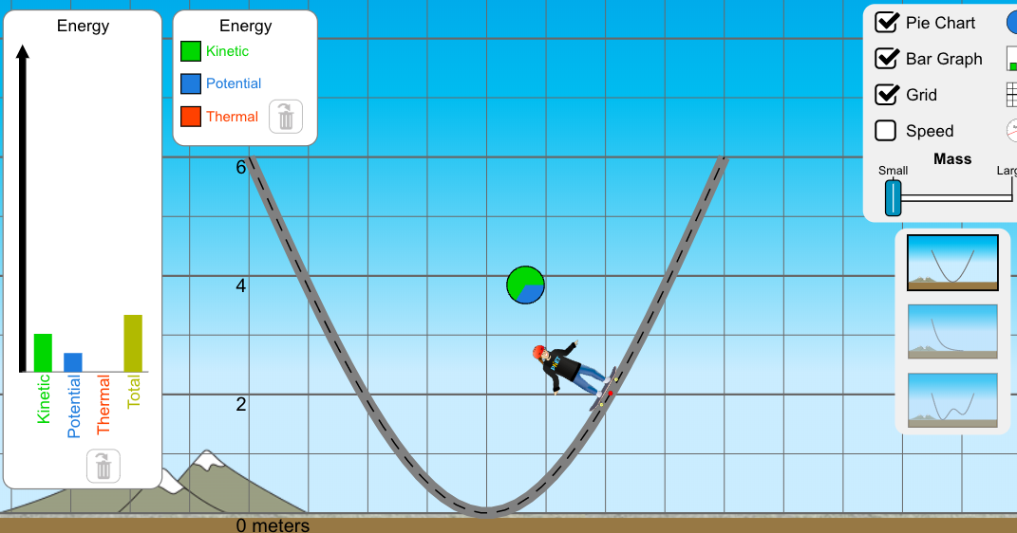
Purpose: Learn about the relationships between potential and kinetic energy.

Set up:
- CUT and PASTE
https://phet.colorado.edu/sims/html/energy-skate-park-basics/latest/energy-skate-park-basics_en.html

- Choose the “INTO” option on the left
- Click the 3 boxes to the right for: Pie Chart, Bar Graph and Grid

Procedures:
- Pick up the skater and place him on the top of the ramp on either side at the “6” line.
  - How far up did the skater go (number wise from the grid)
  - What did you notice about the potential energy (Blue) line in either the Pie chart or the bar graph?
  - What did you notice about the kinetic energy line (Green) in either the Pie chart or the bar graph?
  - What is the relationship between kinetic and potential (Example: As the potential increases the kinetic…..)
- Move the MASS slider in the key to the right to both increase and decrease
  - What do you notice about the relationship between mass and potential/Kinetic energy? (Example: As the mass increases the kinetic…..)
- Select the “friction”
- Click the 3 boxes to the right for Pie Chart, Bar Graph and Grid
- Pick up the skater and place him on the top of the ramp on either side at the “6” line.
- Play round with the friction bar AND mass bars, moving the skater back to the top of the ramp if he stops moving.
  - What do you notice about the relationship between Friction and height? (Example: As the Friction increases the height…..)
- Select the “playground”
- Build a ramp that the skateboarder can go through that completes one loop successfully without changing his Mass or Friction.
  - Show your teacher when you have completed this

