Questions for Refractive Index and Wet Pants

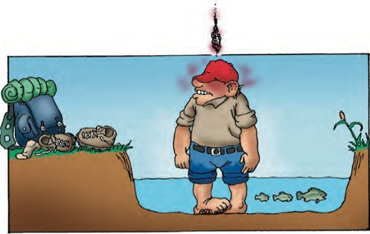
Directions: After reading refractive index and wet pants answer the following questions. Remember to include part of the question in your answer.

- What is refraction? (refracted) When light changes speeds.
- What determines how much the light bends as it passes between objects? The difference between the speeds of light in two transparent materials.
- How do you calculate the refractive index? (What is the formula) speed of light in a vacuum divided by speed of light in the transparent material.
- What does a higher refractive index number mean? The slower the speed of light

Refractive Index
Using the data table on the second page of the reading answer the following questions.
- In which of the transparent materials does light travels the slowest? diamond
- Why did you pick the answer you did? Biggest number in refractive index
- Which of the transparent martials does light travel the quickest? vacuum
- Why did you choose the answer you did? Smallest number in refracted index

Use the formula c/n = refractive index. C stands for speed in a vacuum and n is the speed in the transparent material.

Optical fibers are generally composed of silica. The speed of light through in a vacuum is 300,000 m/s, and the speed of light in the silica is 208,000m/s.
- What is the reflective index of the material? (SHOW YOUR WORK) 300,000/208,000 = 1.44
- Is silica refracting light faster or slower than water? (Hint use the table in the reading) slower because the number if larger

Birdbrains and fishy physics
- Light passing from a material with a lower refractive index to one with a higher refractive index bends towards or away from the normal? Towards the normal
- Using your knowledge of Silica (question 9 &10) if light traveled from air through Silica how would the light refract. Towards because the 2nd medium number is higher
- What evidence do we have that birds, like the great blue heron, understand refraction? They are able to catch fish in water

Extension: At home lab
Procedures:
- Fill a clear (see through) glass or bowl half way with water.
- Put a pencil (or any straight object) in the water.
- Look from the bottom of the glass up through the top.
- What do you notice?
- Remove the pencil and put in the water again
- Again look from the side
- What do you notice? Pencil looks like it is not connected

Watch this 2-minute video
https://www.youtube.com/watch?v=SeaWCamCHWQ

