Reflection/Refraction online inquiry
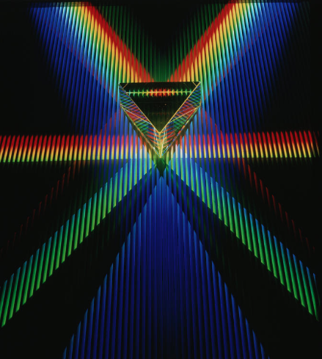
Directions: Write down the purpose and background information on a sheet of notebook.

Purpose: How does light refract and reflect through different mediums?

Background Information:
- Angle of incidence – the angle at which a ray of light strikes the surface of an object.
- Angle of reflection – The angle at which a ray of light reflects off the surface of an object
- Angle of refraction – measure of how much a ray of lights bends when it enters a medium

Procedures:
- Go to the web link on the teachers homepage
https://www.physicsclassroom.com/Physics-Interactives/Refraction-and-Lenses/Refraction/Refraction-Interactive
- Click on the green button that says “go” in the image
- Again click on the green “go” button
- Click on the black button that says, “show protractor” at the top of the page.
- Grab the protractor found in the lower right corner and drag it to the “normal” line
- Grab the black laser box and move it around until it crosses the 50˚ mark of the protractor. You may have to hit go more than once to get it perfectly lined up.
- What line do you measure the angle of incidence or angle of reflection from?
- Show the teacher your purpose, background information, and answer to question 6 to get your data table.
- On the data table which ever medium is first should be on the top and the second medium should be on the bottom.
- After you have finished filling in the data table show it to your teacher.
- Explore using different angles by moving around the laser around and hitting go.
- Answer the Analyzing the data question on the third page using the data you collected.

Medium | Angle of Incidence | Angle of Reflection | Angle of Refraction
Air to water | 50 | 50 | 35
Air to Vacuum
Air to Oil
Air to Diamonds
Vacuum to air
Vacuum to Water
Vacuum to Oil
Vacuum to Diamond
Water to vacuum
Water to Air
Water to Oil
Water to Diamond
Oil to vacuum
Oil to air
Oil to water
Oil to diamond
Diamond to vacuum
Diamond to air
Diamond to Water
Diamond to Oil

Analyzing the data

- Use the data you collected to help you answer the following questions.

- How did the angle of reflection compare to the angle of incidence throughout this lab?
- Back up your answer with data from this inquiry. (Use 2 different specific pieces of evidence)
- Were all the angles of refraction the same as the angles of incidence?
- Explain why you think they were all the same or not all the same measurements?
- Why did some of the angles of refraction bend much more than others?
- What pair of mediums caused the greatest angle of refraction?
- When oil and diamonds were the top medium, why was their no refraction at all?
- Is the angle of reflection ever the same as the angle of refraction for any of the combinations of mediums? If so…specify which pair(s) had the exact same measurements.

- Use BOTH of the following protractor pictures to answer the final two questions (look at your data):
- What do you think the top and bottom mediums are?
- What evidence from your data table helped you to make your decision for each?
